Work Instructions for Carrying out maintenance job on HT system

CARRYING OUT MAINTENANCE JOB ON HT SYSTEM, HT/LT BUSBAR,TRANSFORMERS,SUBSTATIONS,OH LINES,CAPACITOR FEEDER,CAPACITOR AND HT MOTOR

Objective: Working on HT system.

Scope: HT switchgear,substation and overhead lines.

Ref : Indian Electricity rule

- Aspect: Waste genertion
- Impact: Resource depletion
- Hazards: Electric shock/ burns/ flashover , Fall of person from height. Mechanical Hazard: slipping of spanner during tightening or loosening of nut bolts and hitting the hand.Behavioural Hazard: Non adherence to SOP

Responsibility: Electrical Engineer and Electrician .
- Working on HT system/ issuing of Electrical shutdown has to be authorized by the Engineer Incharge.

- Shutdown has to be issued with Lock out/tag out. No one is allowed to work on HT system without proper shutdown permit/ LOTO system

- Before working on any of the above system ensure that switch or breaker contacts are opened
physically and can be seen by nacked eyes. In case the contacts can't be seen than back up switch should be opened OR breaker trolley should be racked out from service position to isolating position OR fuses should be removed as the case may be. Thereafter take electrical shutdown and apply LOTOV. Use arc flash suit while carrying out the operation of switchgear when the system is live and while carrying out the activity of discharging the bus / terminals using standard earth discharge rod.

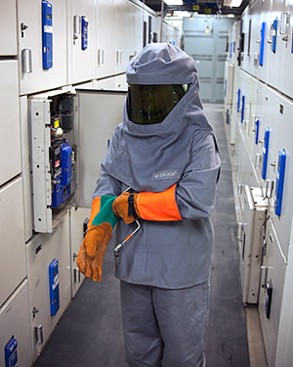

- Once system is disconnected from supply source it should be discharged through certified discharge rod to earth( applicabe to / 11/ 3.3 KV and 415V system and overhead lines) as per the below procedure and let it remain in discharge condition.

- The discharge rod wire has to be clamped to the earthing provided for the panel / motor / transformer / overhead line. All the 3 phases and neutral has to be discharged seperately by touching the earth discharge rod to the busbar/ terminals /overhead line.

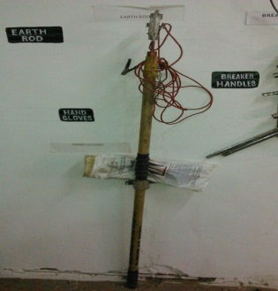

- The discharge rod has to be kept connected to one of the busbars / terminals throughout the maintenace . After discharging all the 3 phase and neutral , all the 3 phases and neutral has to be shorted with the shorting links available in tool room and has to be connected to earth and remain connected to earth while carrying out maintenance on the system.

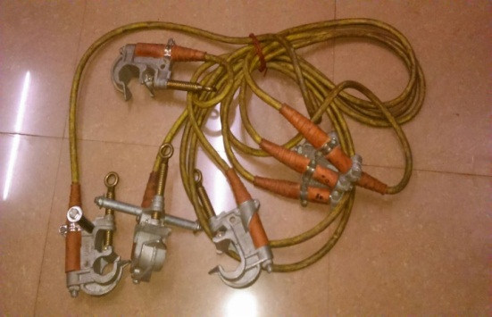

- Nobody should try to check the supply/ current on HT system directly by any tools.HT line voltage and current is displayed on power meters installed on all HT feeders . Nobody should use AC -90 on power contacts of breaker/ busbar contacts.

- Ensure to check and seal any panel openings with piece of aluminuim sheet and anabond. ensure that all nut and bolts of panel doors are tightened and sealed properly.

- After completion of work, first remove earthing connection and then only charge the system.

- Ladder used for working at height shall be safe of use and shall be placed on a stable and levelled surface. Wherever applicable, use safety belt while working at height.

- While giving temporary supply for the feeder during annual shutdown maintenenace of panel, ensure that the original cable all three phase and neutral of that feeder where temporaray supply has to be given is isolated and wires are tapped.This activity has to be cross checked by the Engineer Incharge before switching on temporay supply.

- While checking capacitor current of HT blower motor feeder, after taking s/d of the feeder, disconnect motor power cables from the outgoint terminal. Insulate the cable termination lugs properly with HT insulation sleeves.ensure disconnected cables are tied with armour and minimum clearance of 200mm between diconnected cable terminals & panel outgoing terminals is maintained. Normalise the S/D & switch On the feeder. The current displayed on the Panel meter is the capacitor current. After checking the current normalise the connection & take blower motor direction trial.

Amendement Record
Date | Manual Section Ref. & Para | Brief details of Revision | New Rev.

Prepared By:  Senior Elect. Engineer | Reviewed & Issued By:  Management Representative | Approved By:  Head – Electrical & Instrumentation PID I
Signature | Signature: | Signature:
Review Date: 04.03.2023 | Review Date: 04.03.2023 | Review Date: 04.03.2023

